**LAB – 1: - Introduction to AWS EC2 (Elastic Compute Cloud)**

Name: Naren Chandrashekhar

SRN: PES2UG20CS216

Section: D

1. Summary of instance before launching (Review Instance Launch)

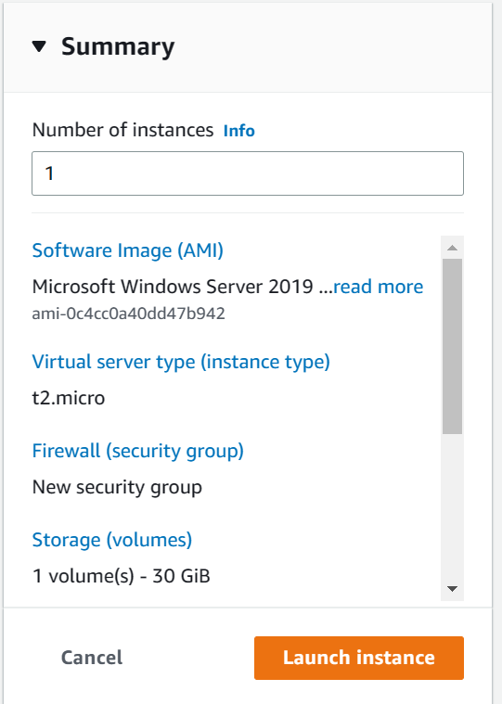

1. EC2 instance in running state

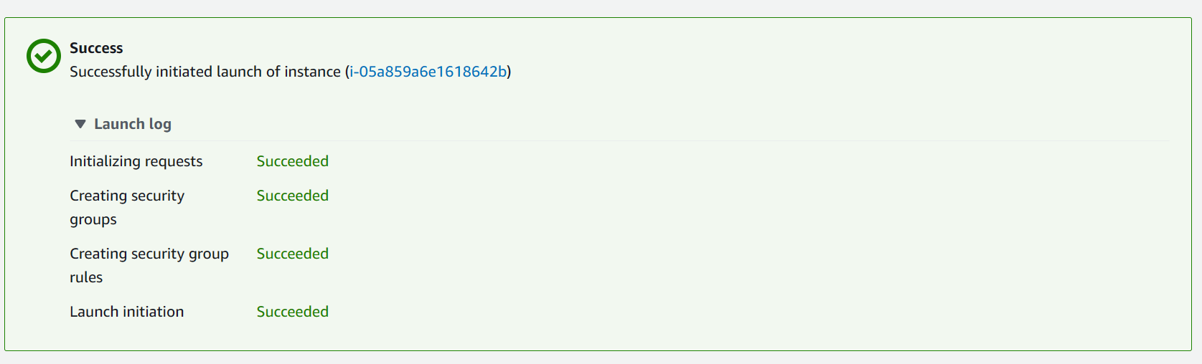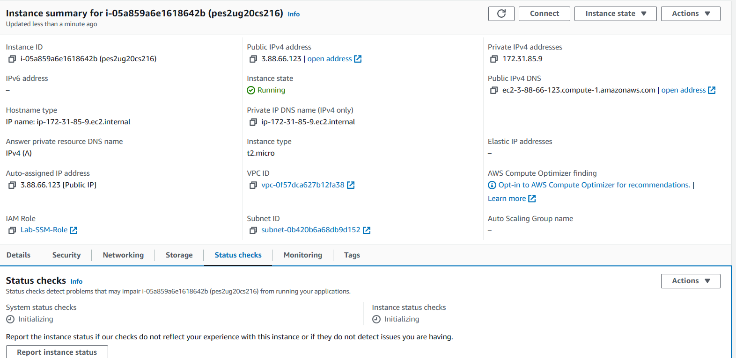

1. Web server browser with the message displaying

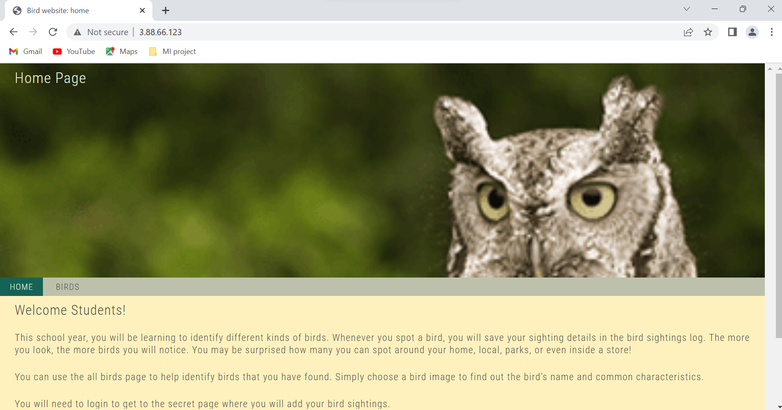

1. Showing the instance volume resized

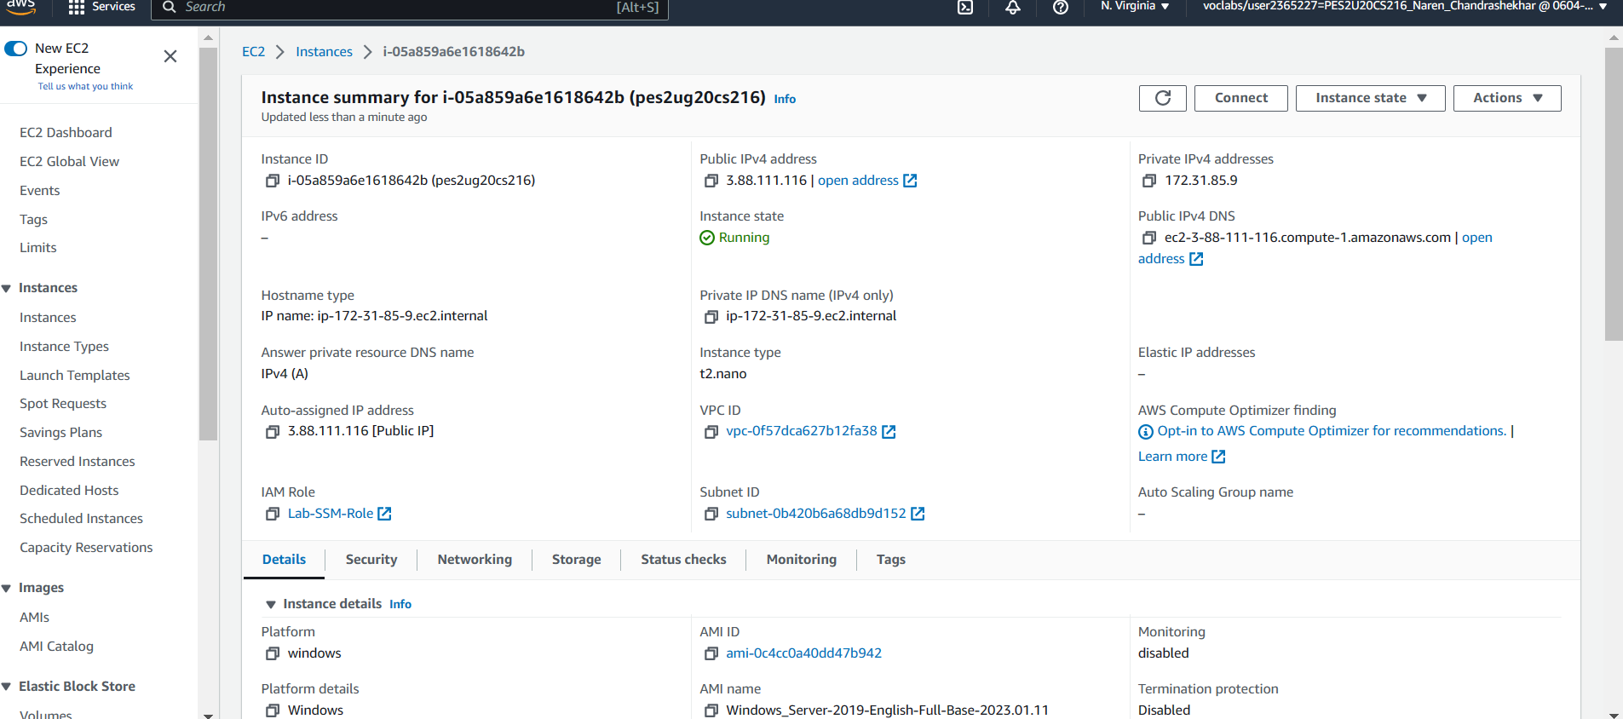

1. EC2 instance in stopped state

